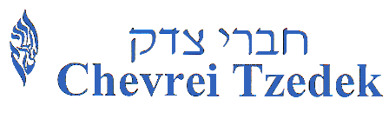

Chevrei Tzedek Congregation
Edward A. Myerberg Center

3101 Fallstaff Road, Baltimore, MD 21209

Phone: 410-542-9110
www.chevreitzedek.org

COVID-19

The following are known symptoms of COVID-19: Fever, cough, shortness of breath, chills, repeated shaking with chills, sore throat, new loss of taste of smell, gastro-intestinal upset, headache or fatigue.

I agree that I will attend a Chevrei Tzedek event and gathering only when ALL of the following statements, at the time of the Chevrei Tzedek event and gathering, are true for ME and ALL of my household members.

1) We are not currently experiencing any of the above symptoms.
2) We have not been diagnosed with COVID-19 nor tested positive for the coronavirus in the past 30 days.
3) We have not knowingly been exposed to anyone with COVID-19 nor someone who has tested positive for the coronavirus within the past 14 days.
4) We have not traveled to nor from any “hot spot” within the past 14 days.

I understand that:
1) A person can unintentionally spread COVID-19 to others even if the person does not feel sick or have symptoms.
2) Masks are meant to reduce the possibility of spreading the virus; they do not block the virus entirely.

By participating in a Chevrei Tzedek sponsored event and gathering, I agree to waive, release and discharge Chevrei Tzedek, and its agents, officers, members and staff, from any and all claims I might have, or any minor child of mine might have, for any personal injury, death, medical expense, other economic loss, or non-economic loss which might be sustained due to exposure to the Covid-19 virus. I also affirm that I have read and understand the attached “Expectations for Those Attending In-Person Events – Chevrei Tzedek Congregation – Summer 2020”, and that I will comply with all requirements and conditions stated therein.

____________________________________ ______________________
SIGNATURE DATE

